Experiment No: - 05
Experiment Name:- DHCP/DNS configuration
Working Procedure:

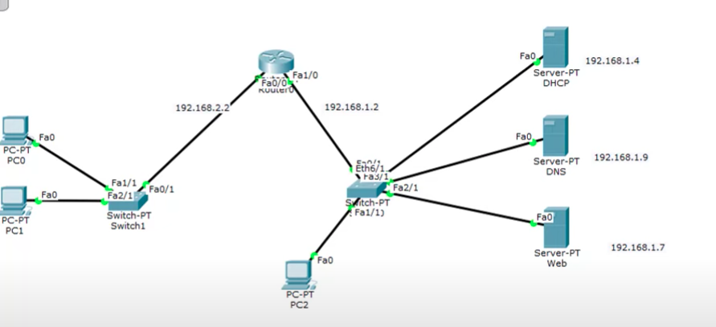

Step By Step Configuration:
Step 1:
- Click on routerconfigurefast ethernet 1give ip address
- Click on routerconfigurefast ethernet 2give ip address
- Click on routerCLI
- ip dhcp pool p1
- network 192.168.1.0 255.255.255.0
- default-router 192.168.1.2
- exit
- ip dhcp pool p2
- network 192.168.2.0 255.255.255.0
- default-router 192.168.2.2

Step 2:
- Click on DHCPdesktopip address
- Click on DHCPdesktopservicedhcpondefault gateway(router ip attached with dhcp) DNS server(ip address of server) save
- Click on DHCPdesktopservicedhcpchange pool namedefault gateway(router ip attached with dhcp) DNS server(ip address of server) add

Step 3(for all PC’s)
- Click on PCdesktopip configdhcp

Step 4:
- Click on DNSdesktopip config
- Click on DNSdesktopip configdhcp ondefault gateway(router ip attached with dhcp) DNS server(ip address of server)

Step 5:
- Click on Web serverdesktopip config
- Click on Web serverdesktopip configdhcp ondefault gateway(router ip attached with dhcp) DNS server(ip address of server)

Step 6:
- Click on DHCPservicesindex.htmldo changing if you want
- Click on DNS servicesindex.htmldo changing if you want
- Click on Web Server servicesindex.htmldo changing if you want

Step 7:
- Click on DNSservicesDNSon name (www format)Address (ip address of DHCP )

Step 8:
- Click on PCdesktopweb browsergive name or ip address to search

SELF STUDY: DHCP RELAY

Router DHCP configuration:
